DENISE SWANSON
http://www.DeniseSwanson.com

BIBLIOGRAPHY — Welcome Back to Scumble River series
featuring school psychologist Skye Denison-Boyd

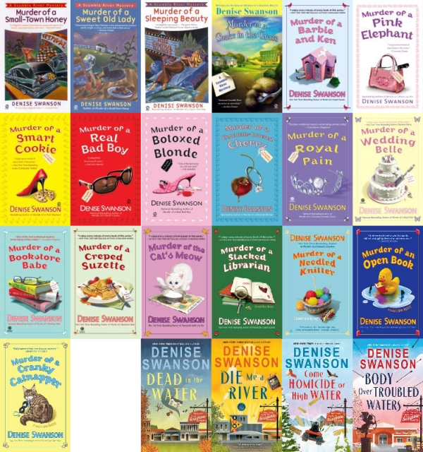

Book 1: Dead in the Water / Sourcebooks, September 2017
ISBN 978-0-4926-4832-1
Book 2: Die Me a River / Sourcebooks, September 2018
ISBN 978-1-4926-4835-2
Book 3: Come Homicide or High Water / Sourcebooks, December 2019
ISBN 978-1-4926-8597-5
Book 4: Body Over Troubled Waters / Sourcebooks, July 2021
ISBN 978-1-4926860-0-2

BIBLIOGRAPHY — Scumble River Mystery series
featuring school psychologist Skye Denison
Book 1: Murder of a Small-Town Honey / Signet, July 2000
ISBN 0-451-20055-1
Book 2: Murder of a Sweet Old Lady / Signet, April 2001
ISBN 0-451-20272-4
Book 3: Murder of a Sleeping Beauty / Signet, April 2002
ISBN 0-451-20548-0
Book 4: Murder of a Snake in the Grass / Signet, April 2003
ISBN 0-451-20834-X
Book 5: Murder of a Barbie and Ken / Signet, November 2003
ISBN 0-451-21072-7
Book 6: Murder of a Pink Elephant / Signet, July 2004
ISBN 0-451-21210-X
Book 7: Murder of a Smart Cookie / Signet, July 2005
ISBN 0-451-21584-2
Book 8: Murder of a Real Bad Boy / Signet, August 2006
ISBN 0-451-21828-0
Book 9: Murder of a Botoxed Blonde / Signet, April 2007
ISBN 978-0-451-22141-4
Book 10: Murder of a Chocolate-Covered Cherry / Obsidian, April 2008
ISBN 978-0-451-22368-5
Book 11: Murder of a Royal Pain / Obsidian, April 2009
ISBN 978-0-451-22658-7
Book 12: Murder of a Wedding Belle / Obsidian, April 2010
ISBN 978-0-451-22961-8 — débuted on The New York Times Best-Sellers List!
Book 13: Murder of a Bookstore Babe / Obsidian, March 2011
ISBN 978-0-451-23280-9 — débuted on The New York Times Best-Sellers List!
Book 14: Murder of a Creped Suzette / Obsidian, October 2011
ISBN 978-0-451-23500-8 — débuted on The New York Times Best-Sellers List!
Book 15: Murder of the Cat's Meow / Obsidian, September 2012
ISBN 978-0-451-23781-1 — débuted on The New York Times Best-Sellers List!
Book 16: Murder of a Stacked Librarian / Obsidian, September 2013
ISBN 978-0-451-41650-6 — débuted on The New York Times Best-Sellers List!
Book 17: Murder of a Needled Knitter / Obsidian, September 2014
ISBN 978-0-451-41651-3
Book 18: Murder of an Open Book / Obsidian, September 2015
ISBN 978-0-451-47211-3
Book 19: Murder of a Cranky Catnapper / Berkley, September 2016
ISBN 978-0-451-47212-0

BIBLIOGRAPHY — Chef-to-Go Mystery series
featuring Danielle Sloan

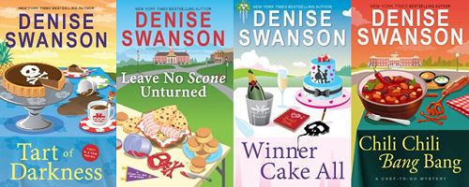

Book 1: Tart of Darkness / Sourcebooks, April 2018
ISBN 978-1-4926-4838-3
Book 2: Leave No Scone Unturned / Sourcebooks, March 2019
ISBN 978-1-4926-4841-3
Book 3: Winner Cake All / Sourcebooks, September 2020
ISBN 978-1-4328-8773-5
Book 4: Chili Chili Bang Bang / Author Denise Swanson, September 2023
ISBN 979-8-9890827-0-4

BIBLIOGRAPHY — Devereaux's Dime Store Mystery series
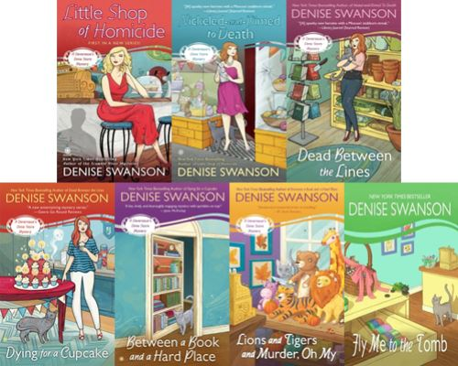

Book 1: Little Shop of Homicide / Obsidian, March 2012
ISBN 978-0-451-23618-0
Book 2: Nickeled-and-Dimed to Death / Obsidian, March 2013
ISBN 978-0-451-23942-6
Book 3: Dead Between the Lines / Obsidian, March 2014
ISBN 978-0-451-41888-3
Book 4: Dying for a Cupcake / Obsidian, March 2015
ISBN 978-0-451-41889-0
Book 5: Between a Book and a Hard Place / Obsidian, March 2016
ISBN 978-0-451-47776-7
Book 6: Lions and Tigers and Murder, Oh My / Berkley, July 2017
ISBN 978-0-451-47777-4
Book 7: Fly Me to the Tomb, Author Denise Swanson, April 2021
ISBN 978-0-9861017-7-9


— Forever Charmed mystery series

Book 1: A Call to Charms / Author Denise Swanson, September 2019
ISBN 978-0-9861017-6-2

Book 2: The Right to Bear Charms / Author Denise Swanson, September 2022
ISBN 978-0-9861017-9-3

BIBLIOGRAPHY — An Apocalyptic Novel

Book 1: Resurrection / Author Denise Swanson, December 2021
ISBN 978-0-9861017-8-6

— Change of Heart romance series
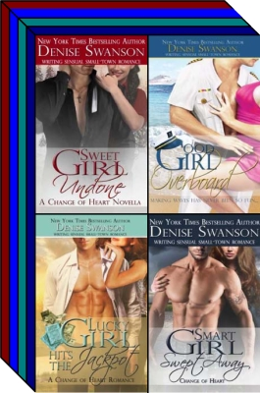
Book 0 — Prequel: Sweet Girl Undone / Author Denise Swanson, October 2015
ISBN 978-0-9861017-3-1 — Novella
Book 1: Good Girl Overboard / Curtis Brown Unlimited, March 2015
ISBN 978-0-9861017-0-0
Book 2: Lucky Girl hits the Jackpot / Author Denise Swanson, October 2015
ISBN 978-0-9861017-1-7
Book 3: Smart Girl Swept Away / Author Denise Swanson, October 2015
ISBN 978-0-9861017-2-4

— Delicious romance series

Book 1: Sinfully Delicious /
Author Denise Swanson, September 2016 * ISBN 978-0-9861017-4-8
Book 2: Dangerously Delicious / Author Denise Swanson, November 2018
ISBN 978-0-9861017-5-5


